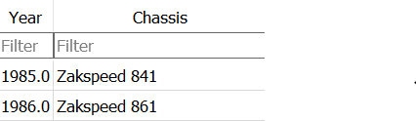

Assume this is the table

Table name: **Zakspeed**

**X variable encoding general structure**

<table_name>,<query_type>,<row>,<col>,<table/row/col/cell data>,<mean>,<median>,etc…..

<table_name>,<query_type>,<row>,<col> these are trivial and already there in the train and test files

**<table/row/col/cell data>**

**Case1:** cell

respresentation

col:data;

Example, cell data of row1, column name chassis is

Chassis:Zakspeed 841;

**Case 2:** row

Representation

col:data;col:data;<more data>;

Example, row summary of row1

Year:1985.0;Chassis:Zakspeed 841;

**Case3:** col

Representation

col:data;data;….more data;

Example, col summary of Year

Year:1985;1986;

**Case 4:** table

Representation

col:data;;

where ;; marks the end of a cell data and the end of a row

Example,

Year:1985.0;Chassis:Zakspeed 841;;Year:1986.0;Chassis:Zakspeed 861;;

Notes

1. Presence of ;; means it is table summary
2. The general format is

col:data;

Basically the cell format, which is then adapted for each of the cases except col case